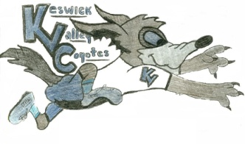KVMS May 19th to May 22nd Activity Challenge
What is it?
Track your Physical Activity each day Tuesday through Friday this week and email crystal.bourgoin@nbed.nb.ca at the end of the week with your complete tracker. If your class is on teams you can send it to me that way too. A prize will be drawn!

What is a tracker?
The day, activity you choose to stay active and the amount of time you spend doing it. Please fill out each day for 4 days. This helps you track how active you are. Remember to get your heart rate up for 30mins.

Below is a list of fun ways to keep up with your Physical Activity to support mental health and well-being during this time:
Family workouts: https://vimeo.com/showcase/6880106
Mini Putt Course: https://www.youtube.com/watch?v=H0c5bC15tcM&t=9s
At Home games and work outs for Phys. Ed: https://drive.google.com/file/d/1myqwWuVSZD5ligm8r20Xhd8wg6_0u4d6/view

Feel free to email me: crystal.bourgoin@nbed.nb.ca . Your teachers love hearing from you! A picture of you participating in one of these activities would be awesome!

